Name: Date:
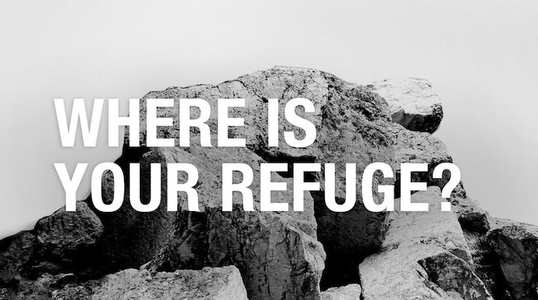
Ref’uge:(n) 1. Shelter or protection from danger or distress 2. That which shelters or protects from danger, or from distress or calamity; a stronghold which protects by its strength, or a sanctuary which secures safety by its sacredness; a place inaccessible to an enemy. 4. a charitable institution for giving shelter and protection to the homeless, destitute, or tempted.

Where is your refuge today? How has it changed throughout your life? Have you ever noticed that as a child your refuge gave you physical comfort such as a secret hiding place, a security blanket, or in a clothing rack as your mother shopped? As you got older your refuge became more abstract, you began to seek comfort with friendships, clothing, peer pressure, or expectations.

Assignment:
Select an age of interest in your childhood or youth that you sought a refuge from something in your life. Your research should be connected to what that refuge provided for you at the time. You will create a work of art that depicts this meaningful time in your life.

Contextual Investigation: (one page)
- Define what a refuge means to you.
- What is the purpose of a refuge?
- Where are refuges located?
- What is provided at a refuge?
- How does a refuge help a person?
- What are some actual refuges?
- What are some abstract refuges?

Conceptual Investigation: (one page)
- Create a brainstorming list for different refuges you have had in your life. Include thumbnails. Remember to think outside the box.
- Explore a variety of different creative solutions and then narrow down your options to the best choice. Explain why you think this will be the most successful route to take.
- This work should be extremely symbolic. This is an opportunity for you to pack your composition with a lot of meaning that can reveal your past experiences. Get personal! Provide in-depth description about the meaning of your refuge and how you want to portray that visually.

Media Investigation: (one page)
- The media is completely open. Think creatively, and work to your strengths. How can you represent this topic in a unique and innovative way? 2D or 3D size limitations no larger than 24" x 36” and no smaller than 12" x 18.”
- Make thoughtful choices about color, composition, and technique that enforce your message. Every mark you make changes the way your viewer will respond to it. Have a very clear idea of how you you want your piece to be read including what you want to both reveal and hide.

Critical Investigation: (one page)
- Find one artist that connects to either your content or form
- Explain this connection - How is this artist relevant?
- Artist Background / Cultural Description / Influences
- Artwork Title / Date / Media / Size
- Description / Analysis / Interpretation / Function & Purpose

Reflective Investigations: (one page for In-Class and one page for At-home)
- How have your investigations directly influenced the direction of your work?
- Take photographs of works in progress!

NOTES:
What ideas immediately came to mind when this project was introduced?

