**Function and Form**

## Function

Conveying a message to an audience should be the central function or purpose of any design. When we start designing, we keep in mind the audience and the message we want to convey. This dictates the form we choose. Think about how your audience perceives your message. Is it something they’re going to see and understand immediately? Or is it something they’re going to have to think about and absorb more slowly? Perhaps your message will be meant to appeal to a small and specific audience, or even a single person. Or you could create messages that are designed to appeal to different audiences, in which case you may use different forms to reach these audiences.

## Form

It’s important to have messages presented in a form that fits their function. Otherwise, it’s like fitting a square peg into a round hole. Even if you’re able to make something look pretty, it could be failing at getting the message across (its primary function) if the form isn’t right. Make sure that you always think of the function before the form, because even the nicest looking design can’t accomplish its goal when it’s not in the right form.

**The shape or form of something should be driven by its intended purpose and function**

In other words, don’t build a beautiful, square-shaped wheel.

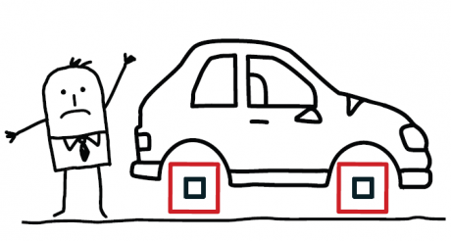

Source: [Function in Design and Marketing](http://finesilverdesign.com/blog/2012/10/22/in-design-and-marketing-function-should-come-before-form/)

**What are the functions of art?**

There are many reasons why artists create. First, proceed with this caution: No piece of art can be "assigned" a function (or functions), either in essay form or in casual conversation, if it isn't first considered within the proper **context**. Trying to classify function depends on context (where, when, and why it was made). The contextual equation also includes you, the viewer in thinking about what the work means to you, living right now. Taking anything out of context can lead to misunderstanding.

**The functions of art fall within various categories. These categories can, and (often) do, overlap.**

**PERSONAL FUNCTION – communicates life experiences, emotions or feelings of an individual**

**EXAMPLE: Expressive Art, Art Therapy**

**SOCIAL FUNCTION** - **addresses aspects of (collective) life, as opposed to one person's point of view or experience, enhances the shared sense of identity of those within a family, community, or civilization**

EXAMPLE: Activist Art, Political Propaganda, Ceremonial Art

**PHYSICAL FUNCTION – performs some service or has a specific use**

EXAMPLE: Architecture, Interior Design, Furniture Design, Utilitarian Art, Crafts

**DECORATIVE FUNCTION - meant to entertain or excite the eye and may not have any meaning at all**

**EXAMPLE: Ornamental Art, Crafts**

**SPRITUAL FUNCTION – expresses beliefs about the destiny of life controlled by a higher power**

**EXAMPLE: Religious Art**

**EDUCATIONAL FUNCTION – symbols and signs that illustrate knowledge, meant to inform or tell a true story**

**EXAMPLE: Science or Math Illustrations, Infographics, Historical or Narrative Art**

**Sources:** [**About.com - Art History**](http://arthistory.about.com/cs/foreducators/f/functions.htm)**,**[**MVHS IB Art - Functions of Art**](http://mvhsibart.weebly.com/functions-of-art.html)

**Form Follows Function**

As a young architect Frank Lloyd Wright worked for Louis Sullivan (1856–1924) in his Chicago-based architectural firm. Sullivan is known for steel-frame construction that led to the emergence of the skyscraper. Sullivan’s famous axiom, “Form follows function,” became the touchstone for many architects. This meant that the purpose of a building should be the starting point for its design. This principle is thoroughly visible in the plan for the Guggenheim Museum. According to Wright’s design, visitors would enter the building, take an elevator to the top and enjoy a continuous art-viewing experience while descending along the spiral ramp.

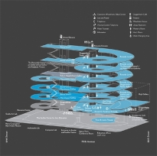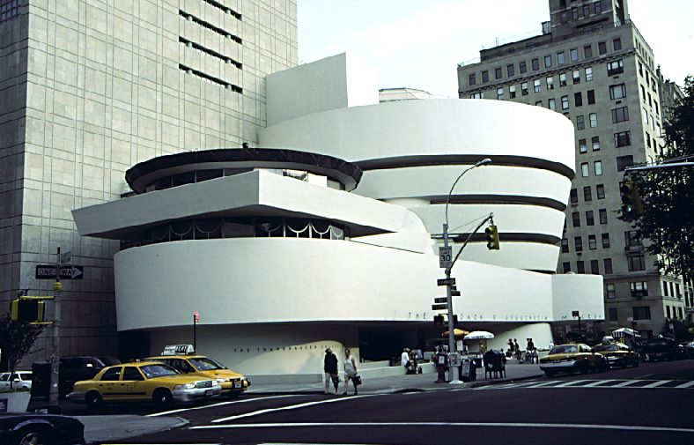

**Source:** [**Guggenheim - Form Follows Function**](http://www.guggenheim.org/new-york/education/school-educator-programs/teacher-resources/arts-curriculum-online?view=item&catid=730&id=120)

**IB Visual Arts: At- Home Assignment**

Choose one function of art that can be the main driving force in your next work.

You should find two artists from different cultures that create works for that same purpose (this research can be used to elaborate on the works you began with your comparative study or you can move in a new direction).

Compare and contrast the works by each of these artists. The work you create should be informed by gaining new knowledge about the artists, concepts, and materials explored.

You must make connections to previous learning, but focus on a new direction that takes earlier work a step further. You could even completely transform a summer piece, infusing it with a new form and function. Though media is optional, the overall function must control the final form.

**Deadline: March 17th – This piece will be due at the beginning of class in order to prepare in for display. We will be hanging your exhibits on this day directly after school. Your final exhibit will have a total of 7 artworks, each accompanied with identification labels and exhibition text. The criteria for your final exhibition are attached. You will begin writing your curatorial rational no later than March 19th.**